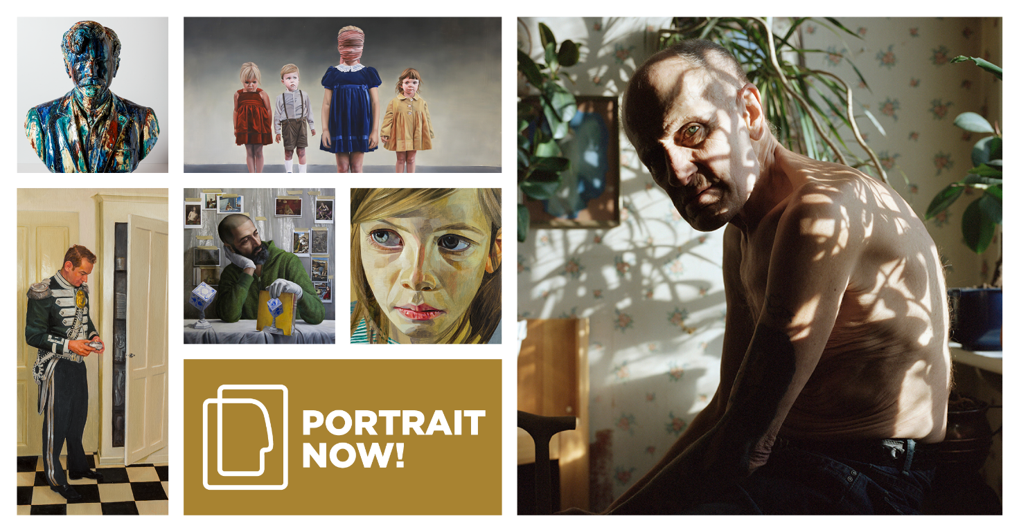
“A good portrait can bring out the essence of a person – it can tell a story and create closeness despite distance in time and place”
Mette Skougaard, Director of the Museum of National History
The Museum of National History’s portrait competition ‘Portrait NOW!’ actualises a genre that, with smartphones and selfies, is more popular than ever before. The competition promotes the basic essence of the portrait genre, where the works, regardless of medium, reflect both the model and the modern age.
Artists residing in the Nordic countries (Denmark, Greenland, the Faroe Islands, Sweden, Norway, Iceland, the Åland Islands and Finland) have until 3 January 2021 to submit portraits for Portrait NOW! The competition is open to entries in all media – paintings, sculptures, photos, videos and installations – and aims to stimulate interest in the portrait genre amongst artists and the general public.
“The portrait genre has never been as popular as it is today, where anyone with a smartphone can take a selfie and photography has become something everyone does every day,” says Mette Skougaard, Director of the Museum of National History. But with Portrait NOW! the Museum of National History is turning the focus onto what makes portraying the individual a distinctive art form: “A good portrait can bring out the essence of a person – it can tell a story and create closeness despite distance in time and place. With Portrait NOW! we want to bring the genre up to date and promote interest in it.”
Portraits, together with historical paintings, tell the history of Denmark at Frederiksborg. For the museum, which is Denmark’s National Portrait Gallery, the competition is about stimulating interest in both classic portraiture and forms of expression in new media.
An international jury will select portraits from among the submitted works to be included in an exhibition at Frederiksborg. The best portraits will receive a Carlsberg Foundation Portrait Award. The award ceremony will take place in May 2021, when the Portrait NOW! exhibition will also open. Since 2007, the Museum of National History at Frederiksborg Castle has held the portrait competition every two years.
About Portrait NOW! 2021
Registration
Portrait NOW! will be open for registration up to 3 January 2021. Works should be registered online at portraitnow.org, where you can also find the rules and guidelines for the competition. Each artist may submit one work.
Media
The competition is open to entries in all media – paintings, sculptures, photos, videos, installations, etc. The essential thing is that the artist should portray a person he or she has met in real life. Otherwise, the choice of subject, method, etc. is up to the individual artist.
Jury
An international jury will evaluate all submitted works and select the portraits to be exhibited at the Museum of National History at Frederiksborg from May 2021.
Christopher Baker, Director of the Scottish National Portrait Gallery, Scotland
Nicholas Cullinan, Director of the National Portrait Gallery, London, England
Mikhail Ovchinnikov, First Deputy Director of the Fabergé Museum, St. Petersburg, Russia
Pontus Ljungberg, Director of the Ljungberg Museum, Ljungby, Sweden
Mette Skougaard, Director of the Museum of National History, Hillerød, Denmark
Prizes
- The first prize is 85,000 Danish kroner
- The second prize is 45,000 Danish kroner
- The third prize is 25,000 Danish kroner
- The Audience Award is 15,000 Danish kroner
- The Young Talent prize is 10,000 Danish kroner
- The special prizes are 10,000 Danish kroner each
Contact: For press material and interviews, contact Communications Manager Sara Juel Andersen (mail: sja@dnm.dk)

Kind regards,
The Museum of National History

